Soft skills practice handout – Student’s version

Part 1: a) Look at the pictures and try to guess which two questions are illustrated by them. Use the gapped sentences below to help you.
Would you rather ________ $50 or flip ___________________________$100?
Would you rather fight _________________ or ____________________?
b) Which skills or traits do these questions test?
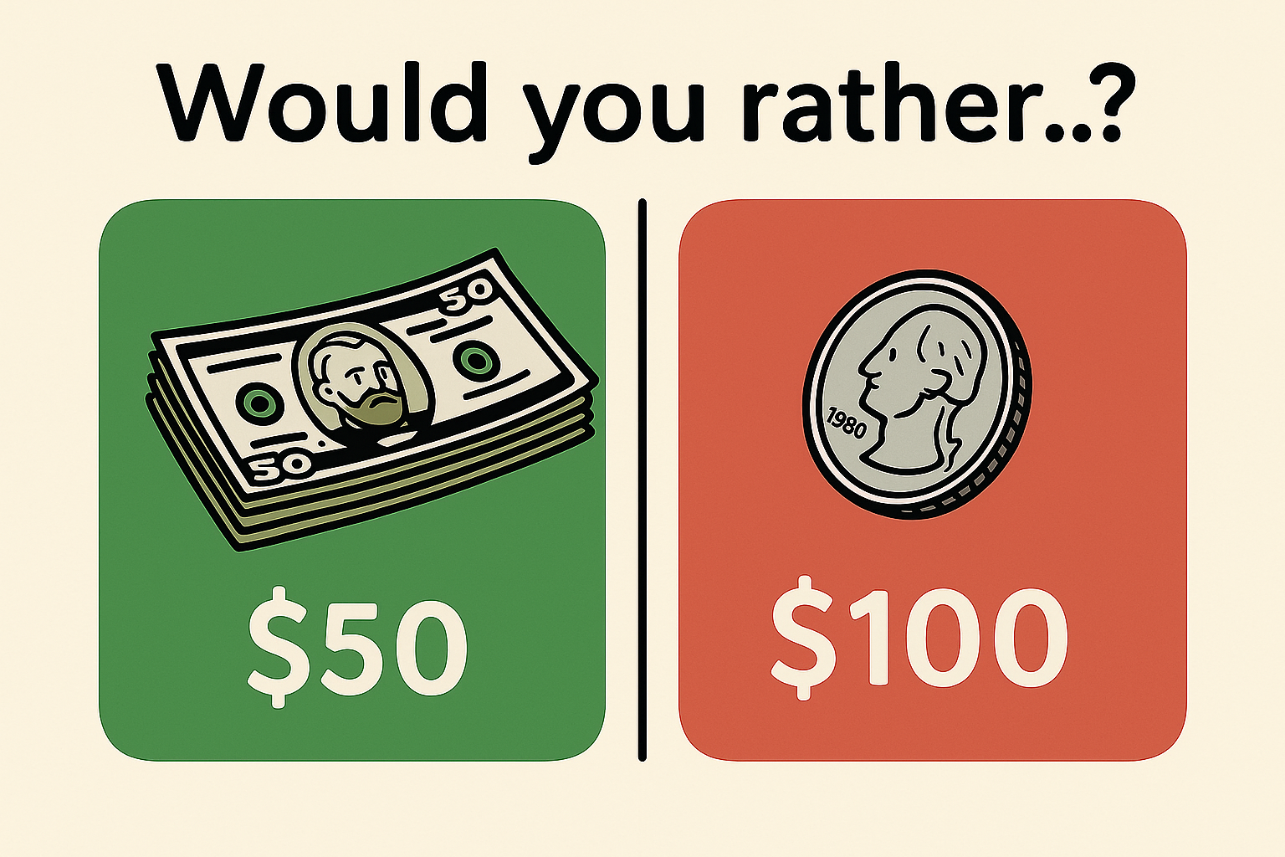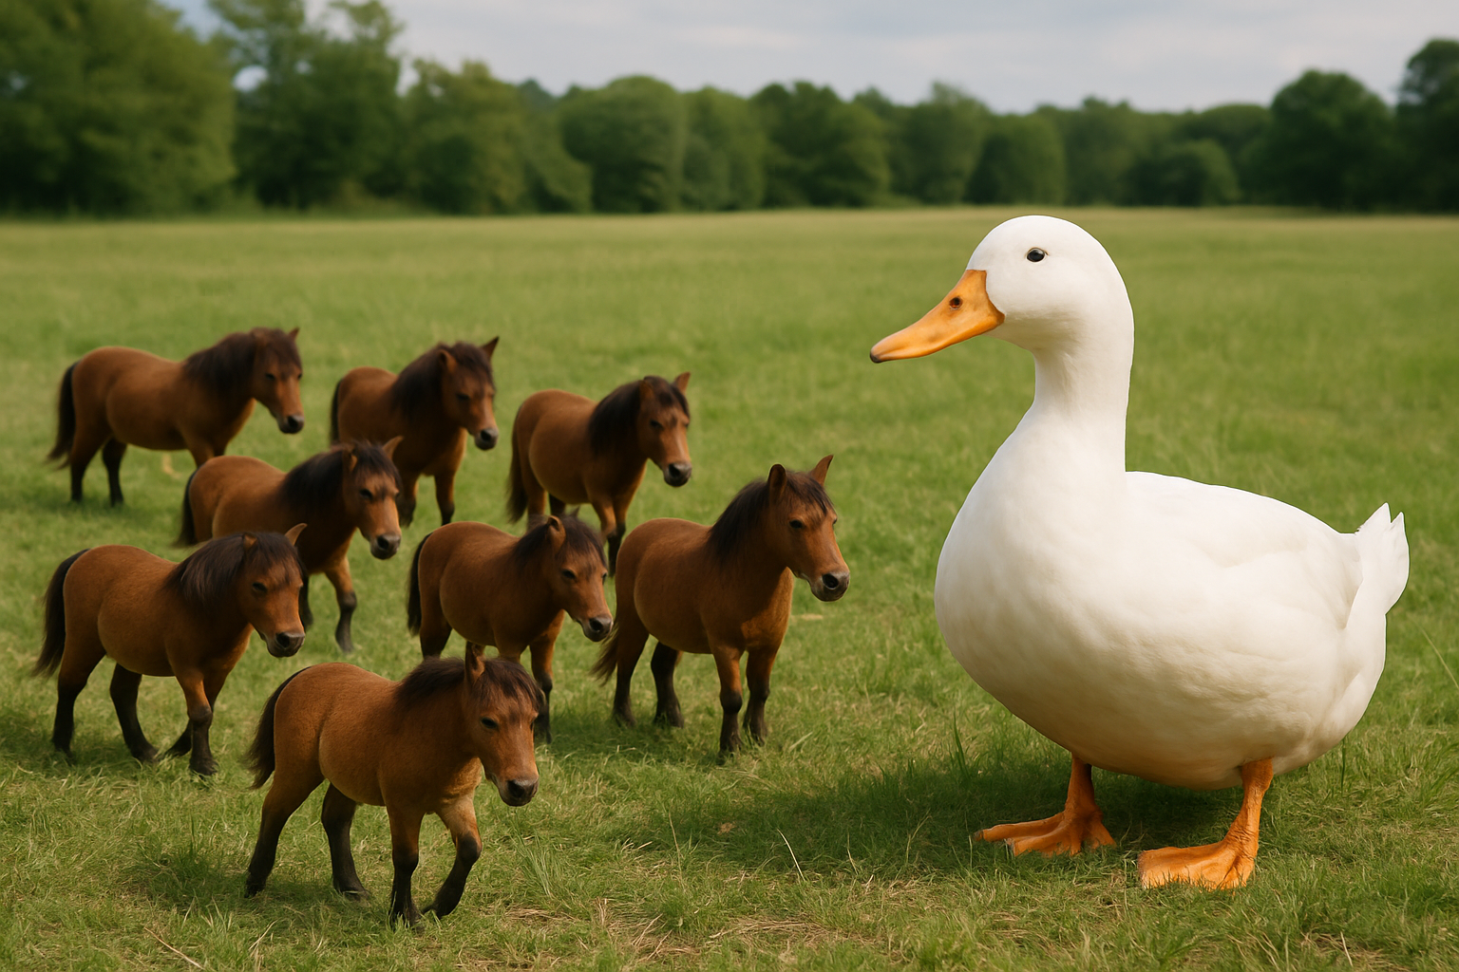

Part 2: Listen to an AI generated podcast and take notes of at least 7 soft skills that are mentioned. After listening compare your notes with a partner.

Part 3: Match each skill or trait with the correct definition. Write the number of the skill next to the corresponding letter. When finished, check your answers with a partner.
🧠 Skills / Traits
- adaptability
- collaboration
- prioritization
- leadership
- culture add
- self-control
- interpersonal skills
- work ethics
- analytical skills
- critical thinking
- emotional intelligence
- culture fit
+ 1 time management

📘 Definitions
A. The process of questioning ideas, identifying weak points in arguments, and using evidence to form well-reasoned judgments rather than accepting things at face value.
B. The ability to build positive relationships through respectful communication, empathy, and active listening, which helps create a cooperative and friendly atmosphere.
C. The ability to influence and support others by giving direction, encouraging progress, and helping a team stay focused on shared objectives.
D. A personal commitment to being dependable, honest, and productive in your duties, often shown through consistency, dedication, and a sense of responsibility.
E. The awareness of your own feelings and the emotions of others, which helps you handle social interactions thoughtfully and respond to situations with care.
F. The skill of deciding what needs your attention first based on importance or urgency, which helps you manage tasks more effectively and avoid delays.
G. The capacity to adjust your actions or mindset when faced with changes in your environment, roles, or expectations, allowing you to stay effective even when situations shift quickly.
H. The value someone brings to a group by contributing fresh ideas, diverse backgrounds, or new ways of thinking that strengthen and expand the team’s overall dynamic.
I. The practice of working closely with others by sharing ideas, solving problems together, and respecting different viewpoints to achieve a common result.
J. The ability to examine information carefully, notice important details or trends, and draw logical conclusions to make sound decisions.
K. A natural alignment between an individual’s values, habits, or way of working and those of a company or team, leading to smooth collaboration and mutual understanding.
L. Managing your emotions, reactions, and behavior, especially under pressure or in difficult situations, to maintain a calm and reasonable approach.
M. The ability to plan your activities wisely so you can complete responsibilities efficiently, avoid unnecessary stress, and meet important deadlines.

Part 4: 🎓 Soft skills interview - practice activity
- Work in pairs or small groups.
- Take turns being the interviewer and the interviewee.
- Ask one question at a time. Listen carefully and ask follow-up questions to get more details.
- Take notes of any interesting answers your partner gives

💬 Interview questions
- Tell me about a time when you had to deal with a sudden change, like a new schedule or unexpected task. How did you handle it?
- Imagine you’re given three tasks with the same deadline, but only time to finish two. How would you decide which ones to complete?
- Have you ever had to work with someone whose approach was very different from yours? What did you do to make it work?
- Can you describe a situation when you helped a group reach a goal or kept a team motivated, even if you weren’t the leader?
- What do you think makes someone a valuable addition to a team, even if they don’t have much experience?
- How do you stay calm or in control when you're frustrated or things don’t go your way?
- What do you do to make a good impression when you’re working with new people?
- Can you give an example of a time when you completed a task or responsibility without being told or reminded?
- Tell me about a time when you had to understand a problem by breaking it into parts. What did you do?
- When someone shares an idea or opinion you don’t agree with, how do you respond?
- Describe a time when you noticed that someone on your team was feeling upset or stressed. How did you respond?
- How would you feel working in an environment where people do things differently from what you're used to?
+1 What helps you stay organized when you have a lot to do in a short time?

🧠 Follow-up discussion
- What skills/ traits are being tested in the questions above?
- Did the answers reflect those skills/ traits well?
- How would you improve your answers next time?
- Why do you think these skills/ traits are important at work?

Sources:
https://toggl.com/blog/100-soft-skills-questions-to-help-you-hire-top-talent
https://business.linkedin.com/talent-solutions/resources/interviewing-talent/behavioral-interview-questions-important-soft-skills
ChatGPT and NotebookLM generated material on the topic of soft skills

