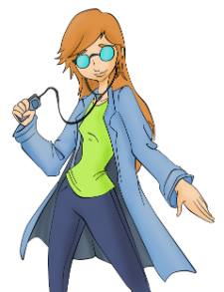***Kenn Nesbitt***

**My Teacher Took My iPod**

*A Funny School Poem for Kids*

*From the book*[*Revenge of the Lunch Ladies*](https://www.amazon.com/dp/1416943641/?tag=poetryforkids)

My teacher took my iPod.  
She said they had a rule;  
I couldn't bring it into class  
or even to the school.  
  
She said she would return it;  
I'd have it back that day.  
But then she tried my headphones on  
and gave a click on Play.  
  
She looked a little startled,  
but after just a while  
she made sure we were occupied  
and cracked a wicked smile.  
  
Her body started swaying.  
Her toes began to tap.  
She started grooving in her seat  
and rocking to the rap.  
  
My teacher said she changed her mind.  
She thinks it's now okay  
to bring my iPod into class.  
She takes it every day.

|  |
| --- |
| **Question 1** |

Why did the teacher take the student's iPod?

|  |  |
| --- | --- |
| A | So she could listen to music. |
| B | She was mean. |
| C | Bringing iPods to school was against the rules. |
| D | She liked to dance |

|  |
| --- |
| **Question 2** |

In the line that reads, "She looked a little startled,"

what does "**startled**" mean?

|  |  |
| --- | --- |
| A | Happy |
| B | Surprised |
| C | Angry |
| D | Sad |
| **Question 3** | |

Why did the teacher change her mind about

the iPod?

|  |  |
| --- | --- |
| A | She liked listening to it. |
| B | She thought the rule was wrong. |
| C | She was hungry. |
| D | She liked clicking the Play button |
| **Question 4** | |

In the line that reads "She started grooving in her

seat" what does "**grooving**" mean?

|  |  |
| --- | --- |
| A | Jumping up and down. |
| B | Correcting homework papers. |
| C | Sleeping. |
| D | Having a fun time. |
| **Question 5** | |

How often does the teacher take the student's iPod

after she changes her mind?

|  |  |
| --- | --- |
| A | Every week. |
| B | Never. |
| C | Every day. |
| D | Every other day |

**Gap-filling exercise**

***Kenn Nesbitt***

**My Teacher Took My iPod**

*A Funny School Poem for Kids*

*From the book*[*Revenge of the Lunch Ladies*](https://www.amazon.com/dp/1416943641/?tag=poetryforkids)

My teacher took my iPod.  
She .................. they had a rule;  
I .................. bring it into class  
or even to the school.  
  
She said she would return it;  
I'd have it .................. that day.  
But then she tried my .................. on  
and gave a click on Play.  
  
She looked a .................. startled,  
but after just a while  
she made sure we .................. occupied  
and cracked a wicked smile.  
  
Her body .................. swaying.  
Her toes began to tap.  
She started grooving in her seat  
and .................. to the rap.  
  
My teacher said she changed her .................. .  
She thinks it's now ..................  
to bring my iPod into class.  
She takes it .................. day.

*Put the following words in the missing spaces.*

**back couldn't said little mind started okay**

**every rocking headphones were**

***Kenn Nesbitt***

**My Teacher Took My iPod**

*A Funny School Poem for Kids*

*From the book*[*Revenge of the Lunch Ladies*](https://www.amazon.com/dp/1416943641/?tag=poetryforkids)

My teacher took my iPod.  
She .................. they had a rule;  
I .................. bring it into class  
or even to the school.  
  
She said she would return it;  
I'd have it .................. that day.  
But then she tried my .................. on  
and gave a click on Play.  
  
She looked a .................. startled,  
but after just a while  
she made sure we .................. occupied  
and cracked a wicked smile.  
  
Her body .................. swaying.  
Her toes began to tap.  
She started grooving in her seat  
and .................. to the rap.  
  
My teacher said she changed her .................. .  
She thinks it's now ..................  
to bring my iPod into class.  
She takes it .................. day.

*Put the following words in the missing spaces.*

**back couldn't said**

**little mind**

**started okay every**

**rocking**

**headphones were**

|  |
| --- |
| **Question 1** |

Why did the teacher take the student's iPod?

|  |  |
| --- | --- |
| A | So she could listen to music. |
| B | She was mean. |
| C | Bringing iPods to school was against the rules. |
| D | She liked to dance |

|  |
| --- |
| **Question 2** |

In the line that reads, "She looked a little startled,"

what does "**startled**" mean?

|  |  |
| --- | --- |
| A | Happy |
| B | Surprised |
| C | Angry |
| D | Sad |
| **Question 3** | |

Why did the teacher change her mind about

the iPod?

|  |  |
| --- | --- |
| A | She liked listening to it. |
| B | She thought the rule was wrong. |
| C | She was hungry. |
| D | She liked clicking the Play button |
| **Question 4** | |

In the line that reads "She started grooving in her

seat" what does "**grooving**" mean?

|  |  |
| --- | --- |
| A | Jumping up and down. |
| B | Correcting homework papers. |
| C | Sleeping. |
| D | Having a fun time. |
| **Question 5** | |

How often does the teacher take the student's iPod

after she changes her mind?

|  |  |
| --- | --- |
| A | Every week. |
| B | Never. |
| C | Every day. |
| D | Every other day |

1. *Remember at least 2* ***excuses*** *the pupil says!*
2. *Why is it hard to* ***fool*** *the teacher?*

**My Teacher Sees Right Through Me**

**by Bruce Lansky**

I didn’t do my homework.  
My teacher asked me, “Why?”  
I answered him, “It’s much too hard.”  
He said, “You didn’t try.”

I told him, “My dog ate it.”  
He said, “You have no dog.”  
I said, “I went out running.”  
He said, “You never jog.”

I told him, “I had **chores** to do.”  
He said, “You watched TV.”  
I said, “I saw the doctor.”  
He said, “You were with me.”

My teacher sees right through my **fibs**,  
which makes me very sad.  
It’s hard to **fool** the teacher  
when the teacher is your dad.

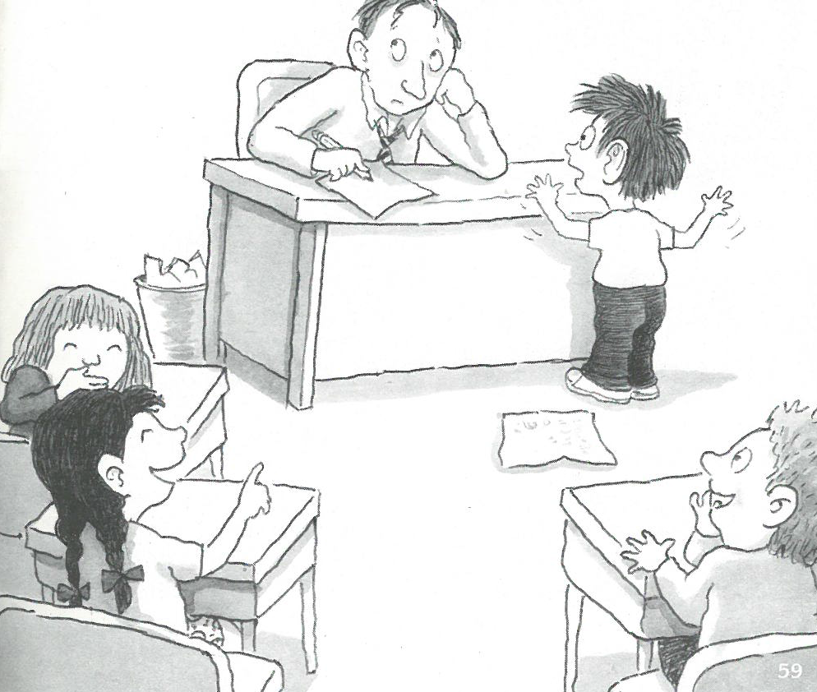

**Kenn Nesbitt -** Sick Day

From the book [*When the Teacher Isn't Looking*](https://www.amazon.com/When-Teacher-Isnt-Looking-School/dp/0684031280/)

I’m feeling sick and getting worse.  
I think *I’d better* see the nurse.  
I’m sure I should go home today.  
It could be fatal if I stay.  
I’m nauseated, nearly ill.  
I have a fever and a chill.  
I have a cold. I have the flu.  
I’m turning green and pink and blue.  
I have the sweats. I have the shakes,  
a stuffy nose, and bellyaches.  
My knees are weak. My vision’s blurred.  
My throat is sore. My voice is slurred.  
I’m strewn with head lice, ticks, and mites.  
I’m covered in mosquito bites.  
I have a cough, a creak, a croak,  
a reddish rash from poison oak,  
a feeble head, a weakened heart.  
I may just faint or fall apart.  
I sprained my ankle, stubbed my toes,  
and soon I’ll start to decompose.  
And one more thing I have today  
that makes me have to go away.  
It’s just as bad as all the rest:  
I also have a science test.

 --Kenn Nesbitt

Copyright © 2005. All Rights Reserved.

**Check-up Questions**

**1. How many illnesses does the poet mention?**

**2. How many symptoms does he describe?**

**3. How many organs of the body can you count?**

**4. Which verbs describe a sound, and which ones describe some movement?**

**5. Is he truly ill?**

**Find synonyms or examples for these words and definition from the text.**

feeling sick …………………………. moist after working out ..……………………….

deadly …………………………. kind of red ………………………….

hazy …………………………. hit ………………………….

removed …………………………. dizzy ………………………….

a type of tree …………………………. became less strong ………………………….

fall into pieces …………………………. trembling ………………………….

clogged …………………………. lose consciousness ………………………….

the biggest “finger” on your feet ……………………………….

little insect that goes under your skin ………………………….

***Kenn Nesbitt & Donna Lee Murphy***

**My Mom’s Speghetti**

*A Funny School Poem for Kids*

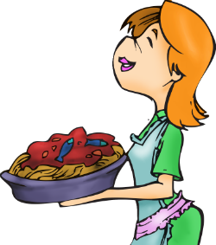My mom makes disgusting spaghetti  
with horseradish sauce and sardines.  
She **tops** it with pickles and mustard,  
bananas and barbecued beans.  
  
She serves it for supper on Sunday.  
On Monday we have it for lunch.  
It's breakfast on Tuesday and Wednesday.  
By Thursday, you guessed it, it's brunch.  
  
I don't like to hurt my mom's feelings.  
I said that I loved it. (I lied.)  
I always gave mine to our doggy.  
And that's why our poor doggy died.  
  
So next time you serve us spaghetti,  
dear mother, don't make it like that.  
Please serve it with red sauce and meatballs,  
and that way it won't kill the cat.

**Check-up Questions**

**1. What’s Mom’s spaghetti like? Is it delicious?**

**2. Write down 2 or 3 things which is on top of Mom’s spaghetti.**

**3. Does the writer like his mother? How do you know that?**